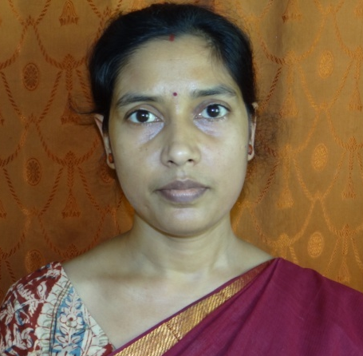
CURRICULUM VITAE

- Name : MONIMALA MONDAL
- Designation : Assistant Professor of Sanskrit (Stage II)
- Address of Correspondence : Department of Sanskrit, Gushkara Mahavidyalaya, P.O. Gushkara,
West Bengal, Pin. 713128.
- Permanent Address : Vill. Lakshmipur, P.O. Barashyambazar, Dist. Burdwan, PIN – 713143, W.B.
- a) E-mail : mondalmonimala@gmail.com
b) Mobile : 9474107972.
- Educational Qualifications :
Examination | Name of the  University/ Board | Year of  Passing | Marks  Obtained (%) | Class/Grade
MP(SE) | WBBSE | 1996 | 70.66 | I
HS | WBCHSE | 1998 | 60.00 | I
B.A. (Hons) | Burdwan University | 2001 | 76.75 | I
M.A. | Burdwan University | 2003 | 73.87 | I
M.Phil | Burdwan University | 2005 | -- | A

- Specialization in MA: Philosophy
- Title of the Ph.D. Thesis (ongoing): ‘Mahabharat’ O ‘Shrimadbhagvat’-e Pratiphalita Samkhyatattver Prekshite Iswwarkrishner Samkhyatattva Bichar

Contd…P/2
Page – 2

- Orientation/Refresher Course/Workshop/Short term Course attended:

Name of the Course/Summer School | Place | Duration | Sponsoring Agency
6th Refresher Course in Comparative Literature | Academic Staff College, BU | 19.06.2010 to 09.07.2010 | UGC
84th Orientation Programme | Academic Staff College, BU | 18.02.2012 to 16.03.2012 | UGC
2nd Refresher Course in Orientalism & Cultural studies | Academic Staff College, BU | 04.02.2015 to 24.02.2015 | UGC
Workshop on National Foundation for Communal Harmony | Human Resource Development Center | 23.06.2016 to 29.06.2016 | UGC
- Publications
Sl. No | Name | Title | Date of Publication | Name of Journal/Publisher
1. | Monimala Mondal | ‘Mahabharate Ullekhito Kotipoy Samkhyatattva’ in S. Batabyal (Ed.) Prabandhamanjusha | 2013 | Amitaranjan Shankaribala Vedavidya Mandir
2. | Monimala Mondal | ‘Prayogatmak Vedanta O Tar Prasangikata’ in Bahuroope Sammukhe Tumi: Vivekananda (Seminar Proceedings) | 2014 | Raniganj Girl’s College, Raniganj
3. | Monimala Mondal | ``Abhijnan Sakuntalam’-e Poribesh-Sachetana Kabi Kalidasa’ in Society and Culture in Ancient India (Seminar Proceedings) | 2015 | Dept. of Sankrit, Univ. of Burdwan
4. | Monimala Mondal | `Swapnadeul’ in S. Majumdar et (Ed.) Phiredekha: Hirak Jayanti Smaranika, 2015 | 2015 | MUC Women’s College, Burdwan
5. | Monimala Mondal | `Prapti’ in S. Majumdar et (Ed.) Phiredekha: Hirak Jayanti Smaranika, 2015 | 2015 | MUC Women’s College, Burdwan
6. | Monimala Mondal | भारत-भागवत-सांख्यदर्शने प्रकृतिस्वरूपम् (Paper Accepted) | 2016 | BORI

